Задача 12. Найти производную.
12.1. 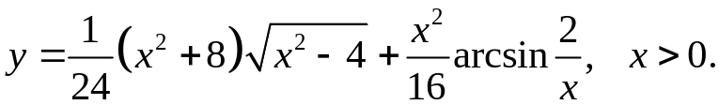
y'= 2x√(x²-4) + x(x²+8) + x/8*arcsin(2/x) – 2x² =
24 24√(x²-4) 16x²√(1-4/x²)
= x³-x + x/8*arcsin(2/x)
8√(x²-4)
12.2. 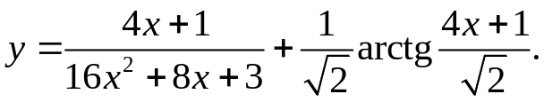
y'= 4(16x²+8x+3)-(4x+1)(32x+8) + 4 =
(16x²+8x+3)² 2(1+(4x+1)²/2)
= 16 _
(16x²+8x+3)²
12.3. 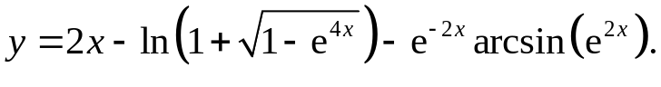
y'= 2 + 2e^{4x} + 2e^{-2x}arcsine^{2x} – 2e^{2x}e^{-2x} =
√(1-e^{4x})(1+√(1-e^{4x})) √(1-e^{4x})
= 2e^{-2x}arcsine^{2x}
12.4.
y'= (9x-6)arctg(3x-2) + 3√(9x²-12x+5) _ 3+(9x-6)/√(9x²-12x+5) =
√(9x²-12x+5) 1+(3x-2)² 3x-2+√(9x²-12x+5)
= (9x-6)arctg(3x-2)
√(9x²-12x+5)
12.5. 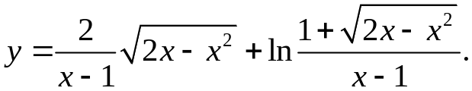
y'= -2√(2x-x²) + 2-2x + (x-1)((1-x)/√(2x-x²)-1-√(2x-x²)) =
(x-1)² (x-1)√(2x-x²) (x-1)²(1+√(2x-x²))
= -1 _ 2 _ 1_
(1+√(2x-x²))√(2x-x²) √(2x-x²)(x-1)² (x-1)
12.6. 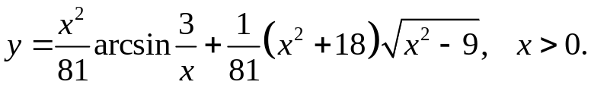
y'= 2xarcsin(3/x) _ 3x² + 2x√(x²-9) _ x(x²+18) =
81 81x²√(x²-9) 81x²√(x²-9) 81x²√(x²-9)
= 2xarcsin(3/x) + x³-39x _
81 81x²√(x2-9)
12.7. 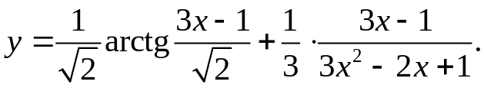
y'= 6 + 3(3x²-2x+1)-(6x-2)(3x-1) = 4 _
2(2+(3x-1)²) 3(3x²-2x+1)² 3(3x²-2x+1)²
12.8. 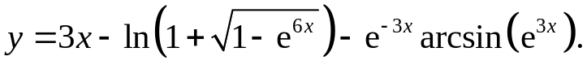
y'= 3 + 3e^{6x} + 3e^{-3x}arcsin(e^{3x}) – 3e^{-3x}e^{3x} =
√(1-e^{6x})(1+√(1-e^{6x})) √(1-e^{6x})
= 3e^{-3x}arcsin(e^{3x})
12.9.
y'= 16x-4+4√(16x²-8x+2) _ (16x-4)arctg(4x-1) _ 4√(16x²-8x+2) =
(4x-1+√(16x²-8x+2)√(16x²-8x+2) √(16x²-8x+2) 2+16x²-8x
= (4-16x)arctg(4x-1)
√(16x²-8x+2)
12.10. 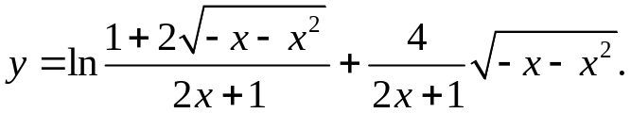
y'= (2x+1)((-1-2x)/√(-x-x²)-2-4√(-x-x²)) + (-2-4x)(2x+1)/√(-x-x²)-8√(-x-x²) =
(2x+1)²(1+2√(-x-x²)) (2x+1)²
= 4x+4x² _ 3 _
(2x+1)√(-x-x²)(1+2√(-x-x²)) (2x+1)√(-x-x²)
12.11.
y'= 4(2x+3)³arcsin(1/(2x+3)) – 2(2x+3)⁴ + 2/3*(8x+12)√(x²+3x+2) +
√(4x²+12x+8)
+ 2(4x²+12x+11)(2x+3) = 4(2x+3)³arcsin(1/(2x+3)) – 8/3*(2x+3)√(x²+3x+2)
3√(x²+3x+2)
12.12. 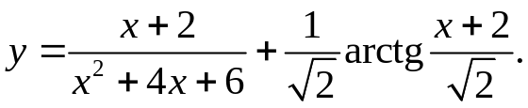
y'= x²+4x+6-(2x+4)(x+2) + 2 = 4 _
(x²+4x+6)² 2(2+(x+2)²) (x²+4x+6)²
12.13. 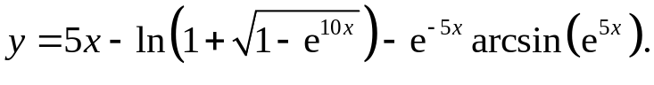
y'= 5 + 5e^{10x} + 5e^{-5x}arcsin(e^{5x}) – 5e^{-5x}e^{5x} =
√(1-e^{10x})(1+√(1-e^{10x})) √(1-e^{10x})
= 5e^{-5x}arcsin(e^{5x})

12.14.
y'= (x-4)arctg(x-4) + √(x²-8x+17) _ √(x²-8x+17)+x-4 =
√(x²-8x+17) x²-8x+17 (√(x²-8x+17)+x-4)√(x²-8x+17)
= (x-4)arctg(x-4)
√(x²-8x+17)
12.15. 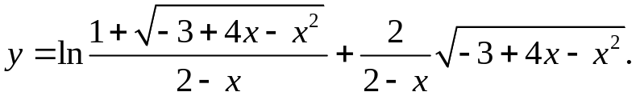
y'= (2-x)((2-x)²/√(-3+4x-x²)+1+√(-3+4x-x²)) + 2(4-2x)(2-x)/√(-3+4x-x²)+2√(-3+4x-x²) =
(2-x)²(1+√(-3+4x-x²)) (2-x)²
= x²-5x+7 _
(2-x)√(-3+4x-x²)
12.16.
y'= (6x-4)√(9x²-12x+3) + (3x²-4x+2)(9x+6) + 12(3x-2)³arcsin(1/(3x-2)) –
√(9x²-12x+3)
- 9(3x-2)⁴ = 12(3x-2)³arcsin(1/(3x-2)) - 6(3x-2)³ _
√(1-1/(3x-2)²)(3x-2)² √(9x²-12x+3)
12.17. 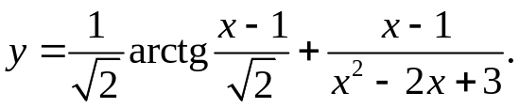
y'= 2 + x²-2x+3-(x-1)(2x-2) = 4 _
2(3+x²-2x) (x²-2x+3)² (x²-2x+3)²
12.18. 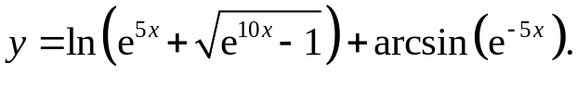
y'= 5e^{5x}(1+√(e^{10x}-1)) _ 5e^{-5x} =
√(e^{10x}-1)(1+√(e^{10x}-1)) √(1-e^{-10x})
= 5√(e^{5x}-1)
√(e^{5x}+1)
12.19.
y'= 2+(4x-6)/√(4x²-12x+10) _ (4x-6)arctg(2x-3) _ 2√(4x²-12x+10) =
2x-3+√(4x²-12x+10) √(4x²-12x+10) √(4x²-12x+10)
= (6-4x)arctg(2x-3)
√(4x²-12x+10)
12.20. 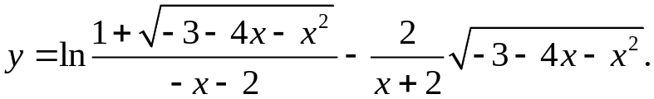
y'= (-2-x)((-2-x)²/√(-3-4x-x²)+1+√(-3-4x-x²)) + 2√(-3-4x-x²) + 4+2x =
(-2-x)²(1+√(-3-4x-x²)) (2+x)² (2+x)√(-3-4x-x²)
= -x _
(2+x)²√(-3-4x-x²)
12.21.
y'= 2/3*(8x-4)√(x²-x) + (4x²-4x+3)(2x-1) + 8(2x-1)³arcsin(1/(2x-1)) – 2(2x-1)⁵ =
3√(x²-x) (2x-1)²√(4x²-4x)
= 8(2x-1)³arcsin(1/(2x-1))
12.22. 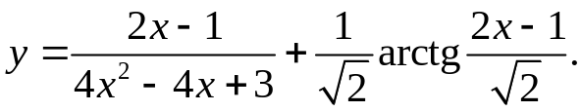
y'= 2(4x²-4x+3)-4(2x-1)² + 4 = 8 _
(4x²-4x+3)² 2(4x²-4x+3) (4x²-4x+3)²
12.23. 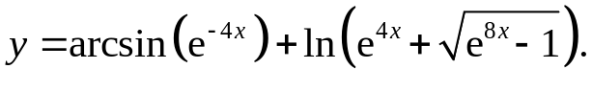
y'= -4e^{-4x} + 4e^{4x}+4e^{8x}/√(e^{8x}-1) = 4√(e^{4x}-1)
√(1-e^{-8x}) e^{4x}+√(e^{8x}-1) √(e^{4x}+1)
12.24. 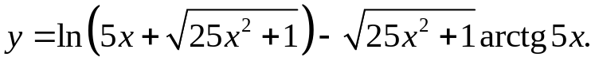
y'= 5+25x/√(25x²+1) _ 25xarctg5x _ 5√(25x²+1) = _ 25xarctg5x
5x+√(25x²+1) √(25x²+1) 25x²+1 √(25x²+1)
12.25. 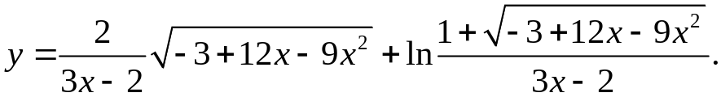
y'= -6√(-3+12x-9x²) + 12-18x + (3x-2)((6-9x)(3x-2)/√(-3+12x-9x²)-3-3√(-3+12x-9x²)) =
(3x-2)² (3x-2)√(-3+12x-9x²) (1+√(-3+12x-9x²))(3x-2)²
= -9x-2 _
(3x-2)²√(-3+12x-9x²)
12.26.
y'= 12(3x+1)³arcsin(1/(3x+1)) – 3(3x+1)⁵ + (6x+2)√(9x²+6x) +
√(9x²+6x)(3x+1)²
+ (3x²+2x+1)(9x+3) = 12(3x+1)³arcsin(1/(3x+1)) + 18x²(3x+1)/√(x²+3x+2)
√(9x²+6x)
12.27. 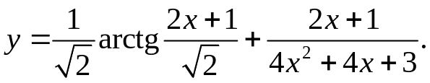
y'= 2 + 8x²+8x+6-16x²-16x-4 = 5-4x²-4x _
2(3+4x²+4x) (4x²+4x+3)² (4x²+4x+3)²
12.28. 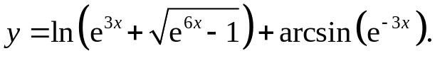
y'= 3e^{3x}(e^{3x}+√(e^{6x}-1)) _ 3e^{-3x} =
√(e^{6x}-1)(e^{3x}+√(e^{6x}-1)) √(1-e^{-6x})
= 3√(e^{3x}-1)
√(e^{3x}+1)
12.29. 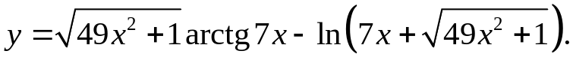
y'= 49xarctg7x + 7√(49x²+1) _ 7+49x/√(49x²+1) = 49xarctg7x
√(49x²+1) 49x²+1 7x+√(49x²+1) √(49x²+1)
12.30. 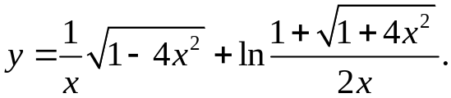
y'= -√(1-4x²) _ 4x + 2x(4x²/√(1+4x²)-1-√(1+4x²)) = -1 _ 1 _
x² x√(1-4x²) 2x²(1+√(1+4x²)) x²√(1-4x²) x√(1+4x²)

12.31. 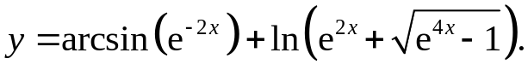
y'= -2e^{-2x} + 2e^{2x}+2e^{4x}/√(e^{4x}-1) = 2√(e^{2x}-1)
√(1-e^{-4x}) e^{2x}+√(e^{4x}-1) √(e^{2x}+1)

